Project -3

Trend Store

1. Git fork from <https://github.com/sriram-R-krishnan/devops-build> to https://github.com/Bhuvisai22
2. Docker:

* Dockerized the application by creating a Dockerfile

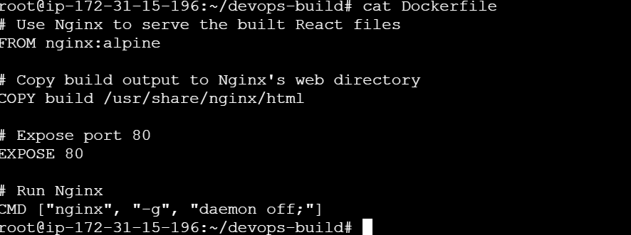

* Docker images and container created:

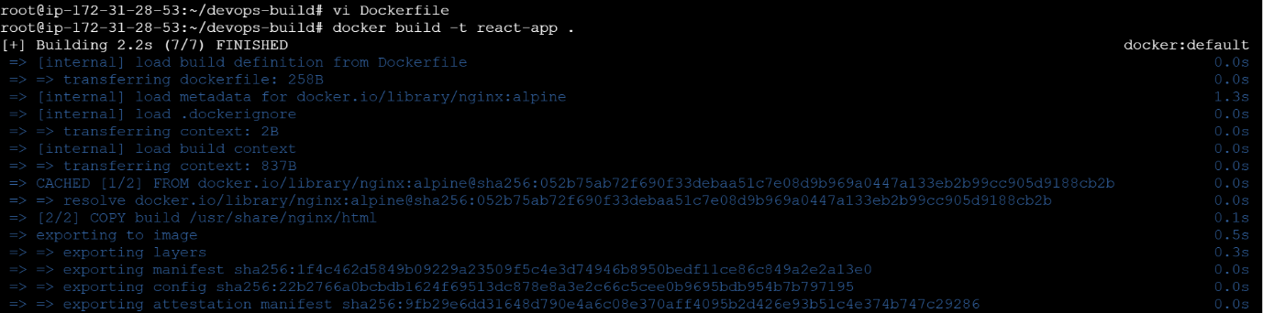

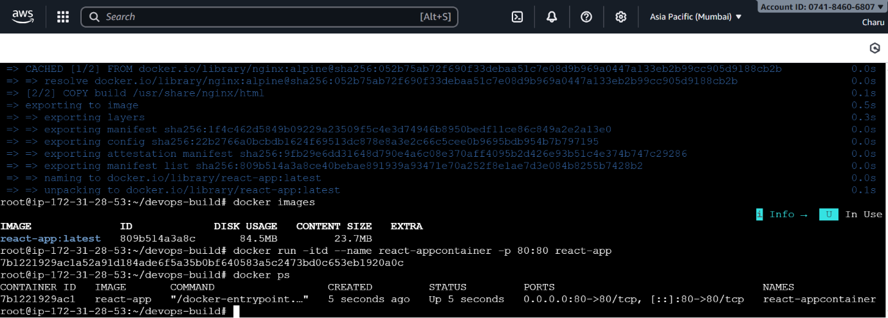

* Output:

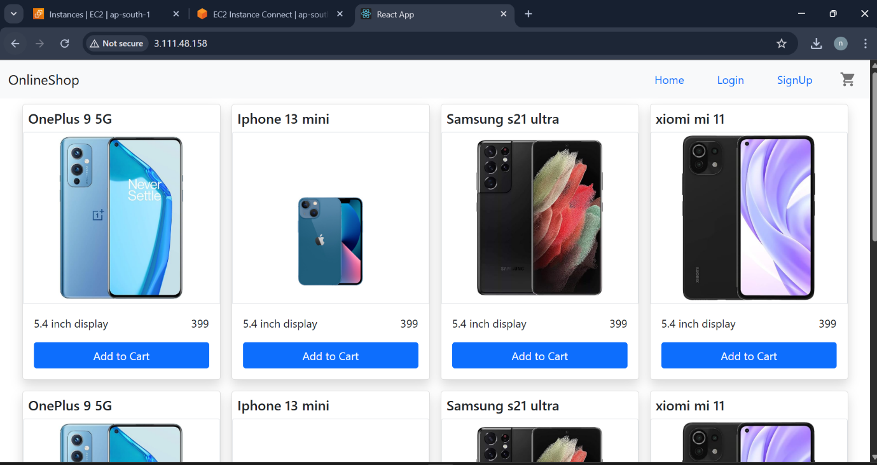

1. Created a docker-compose and docker-compose file to use the above image: 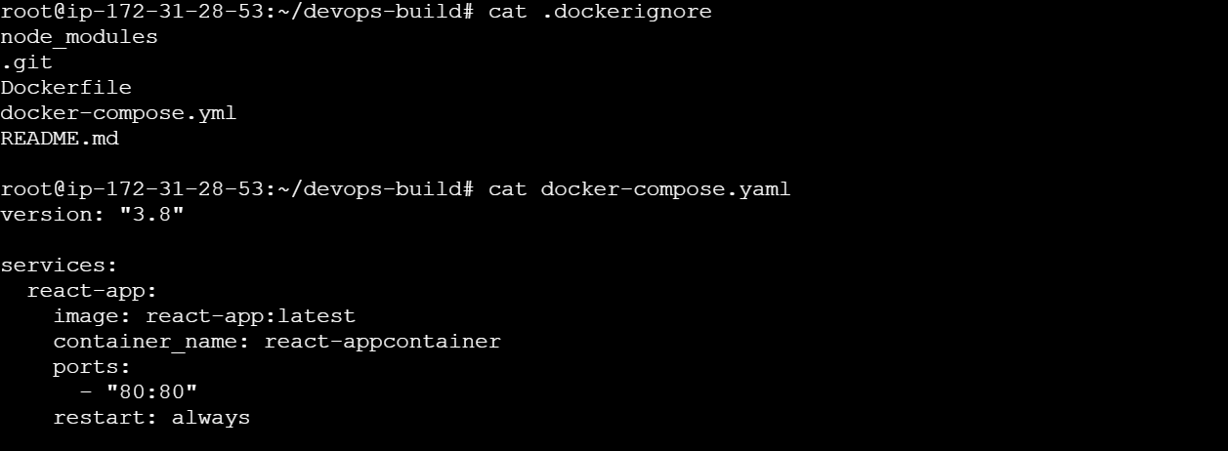

* By using the command docker-compose up -d, container was created 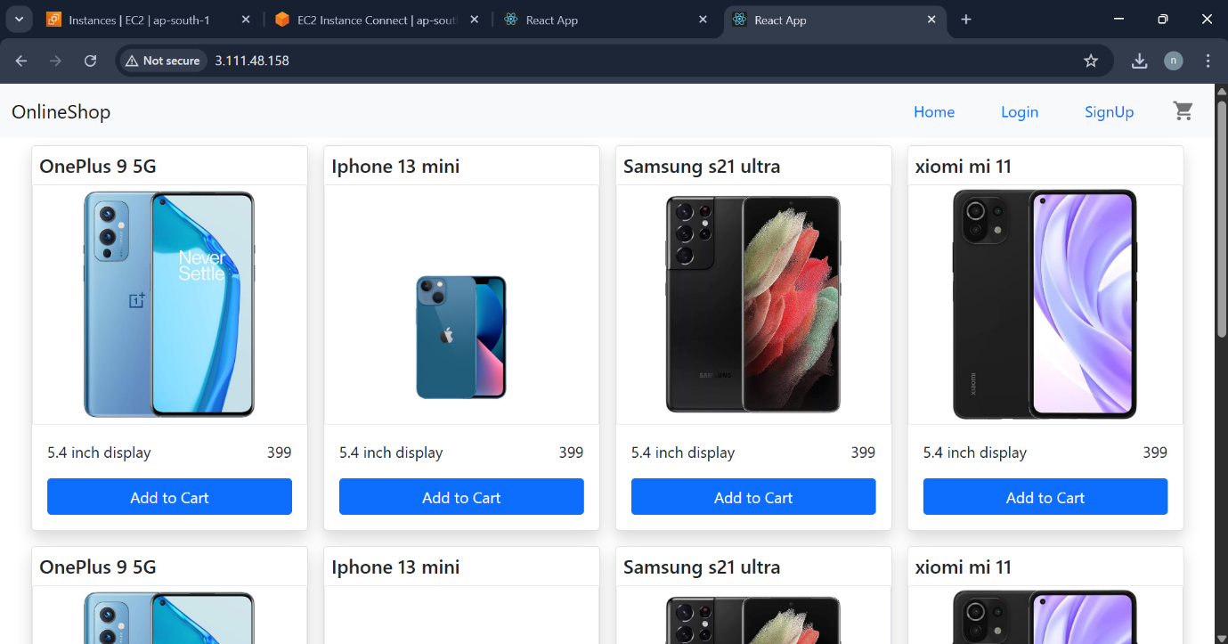

4. Bash Scripting:

* build.sh - for building docker images, deploy.sh - for deploying the image to server
* build.sh file: 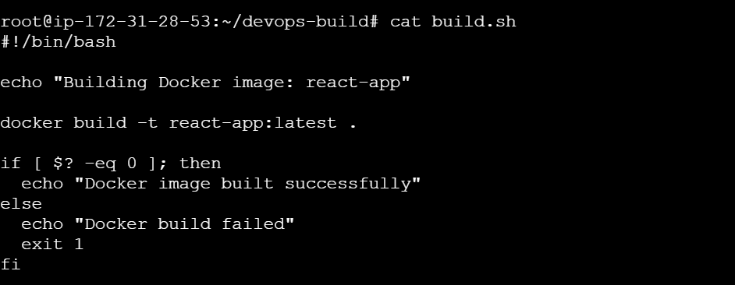
* Deploy.sh file:

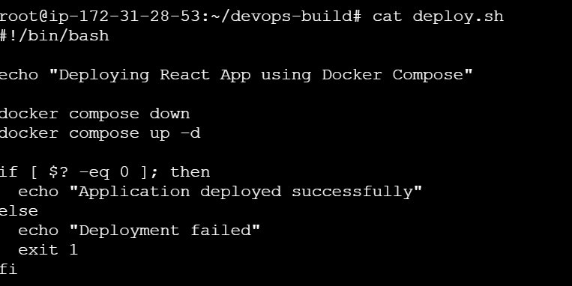

1. Version Control:

* Pushed the code to github to dev branch
* Fiiles pushed to GITHUB
* Commands used as below:
* **Commands:**
  + git init
  + git checkout -b dev1
  + git add .
  + git commit -m "Initial commit with dockerization"
  + git remote add origin https://github.com/Bhuvisai22/devops-build.git
  + git push origin dev

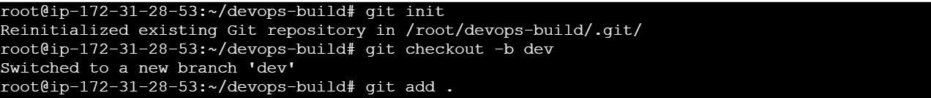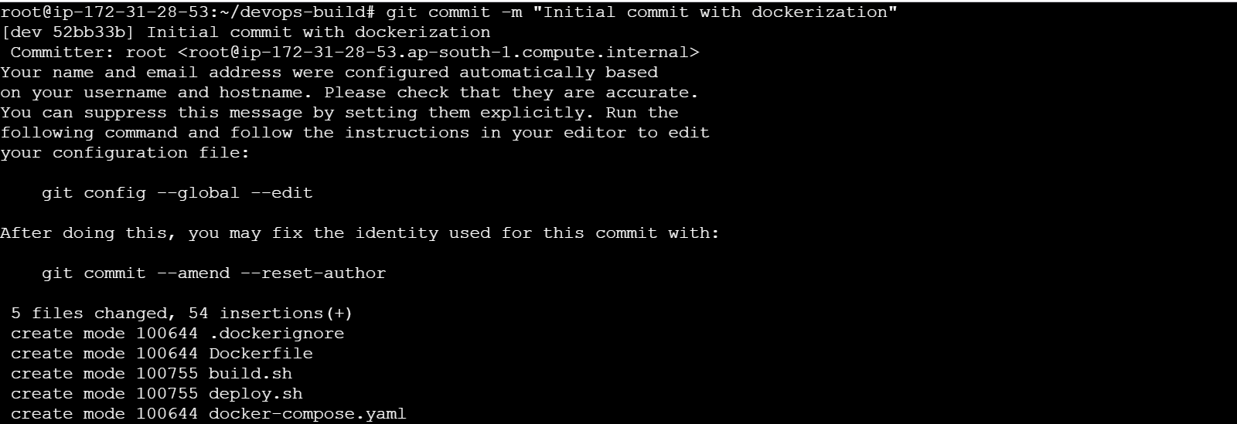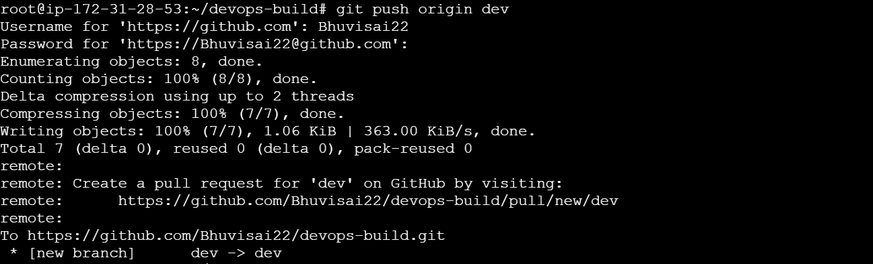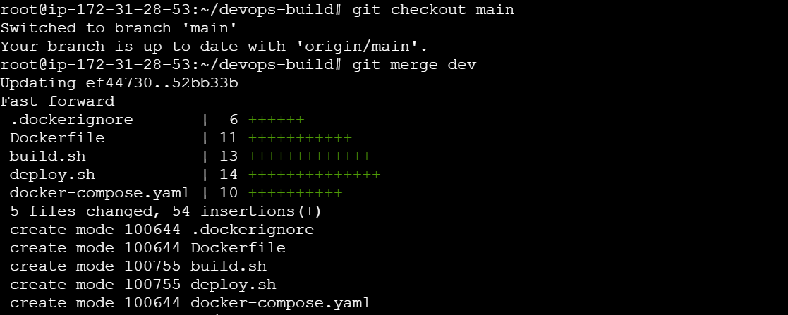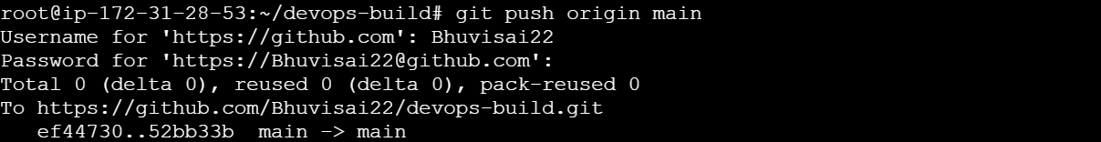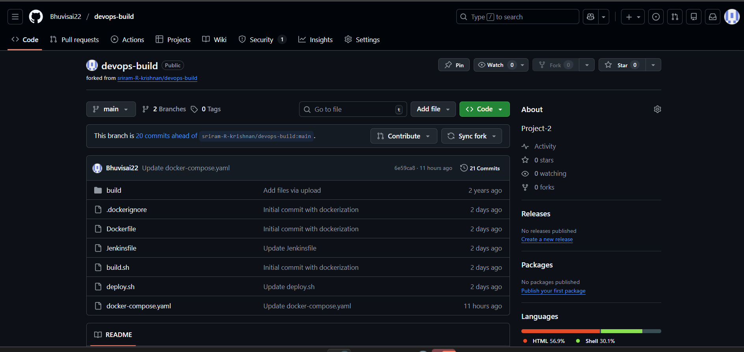

1. Docker hub:

* Logined to Docker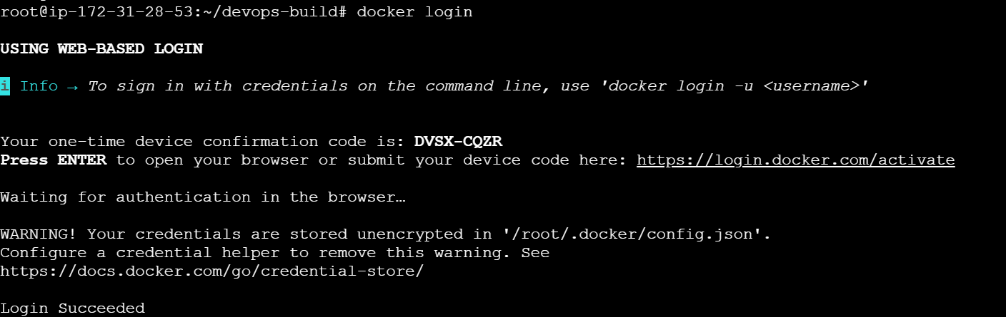
* Docker tag and push image to dev repo:

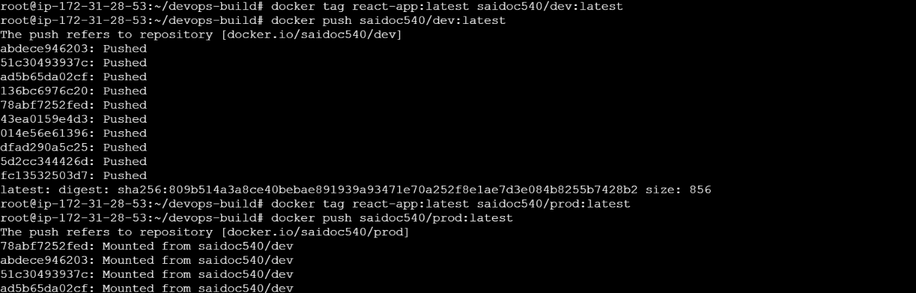

* Docker images mounted to Prod repo: 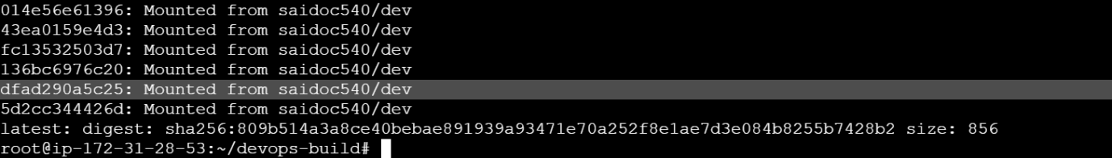 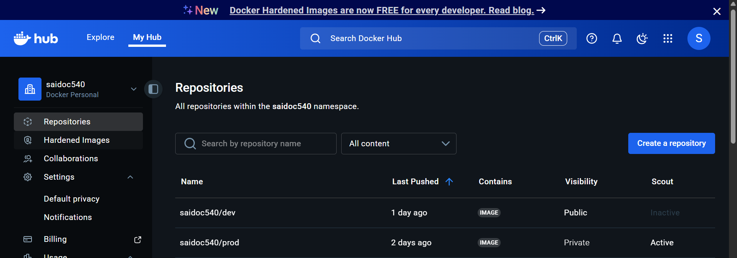 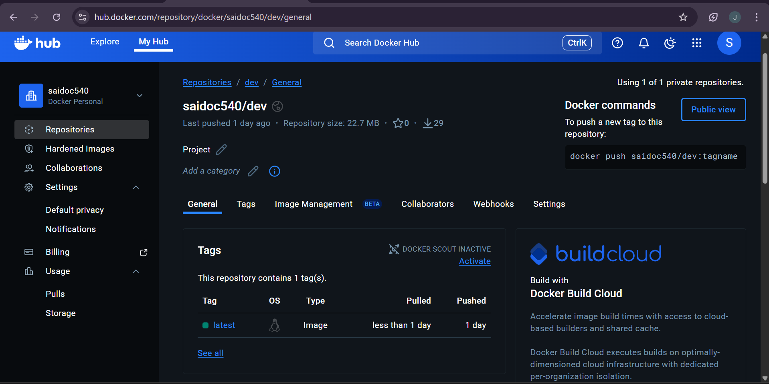 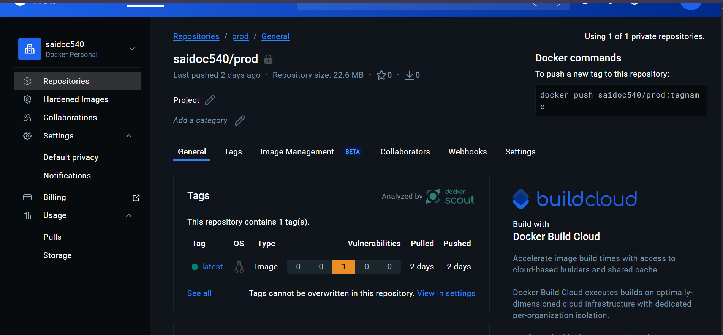

1. Jenkins:

Installed Jenkins 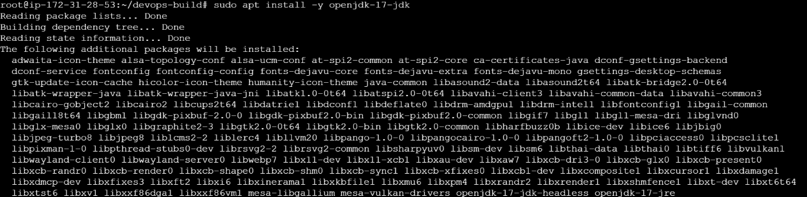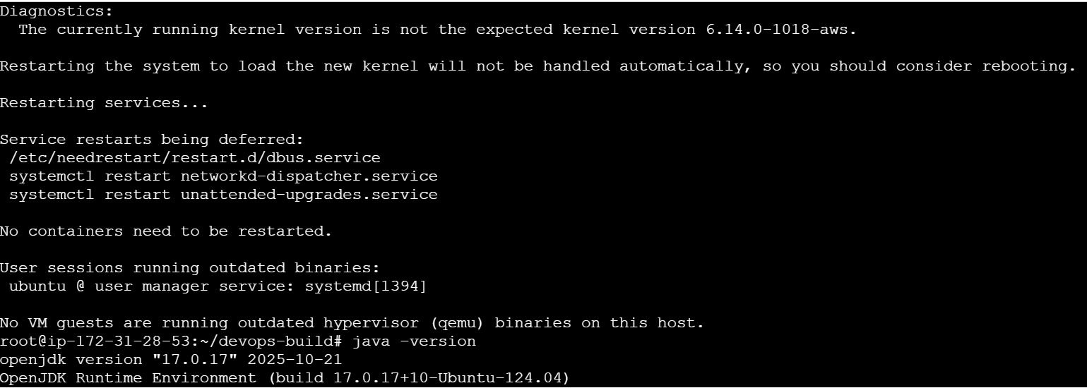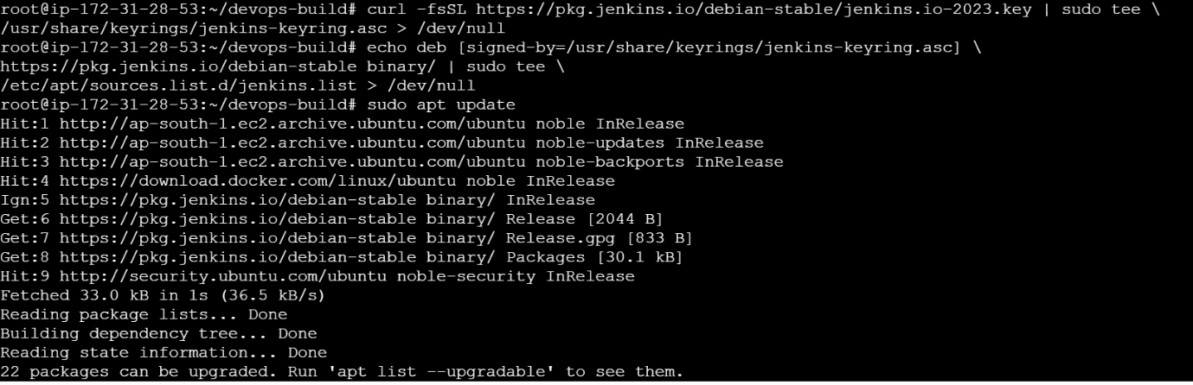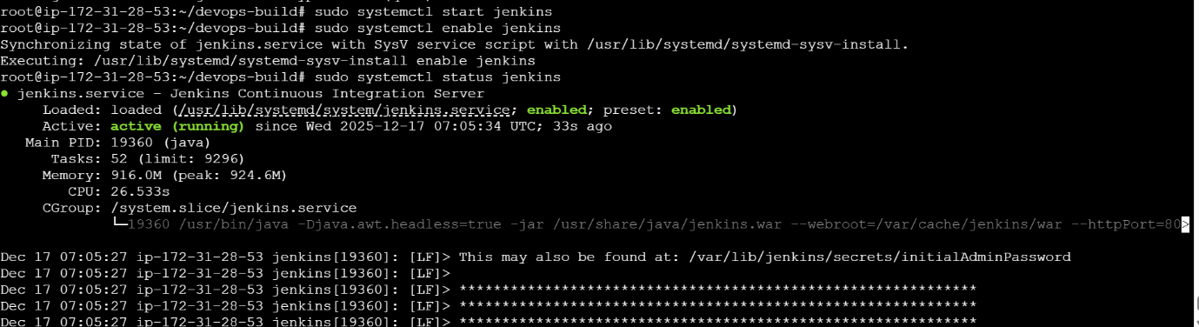

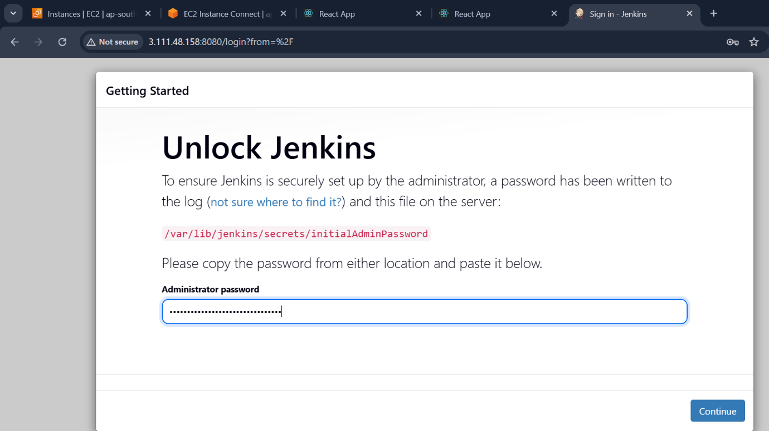



* Created a Multibranch Pipeline for dev and main brances in GITHUB : 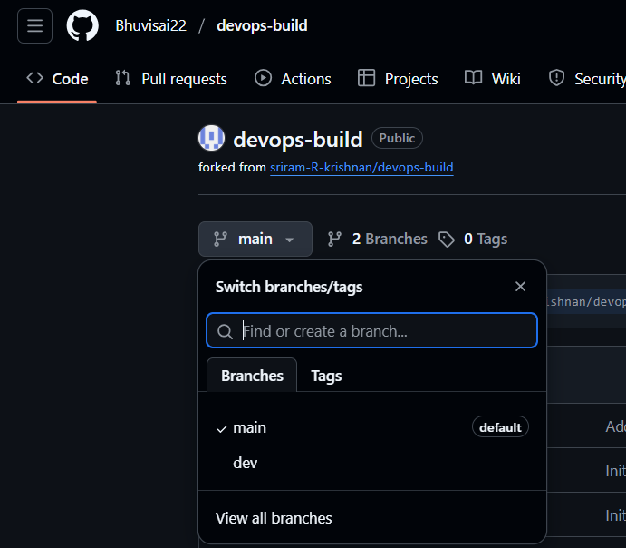

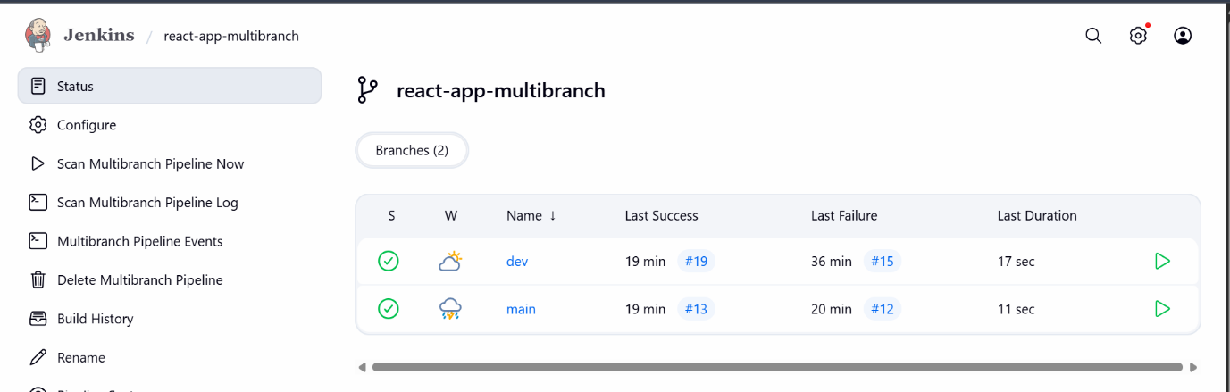

* Jenkins pipeline: 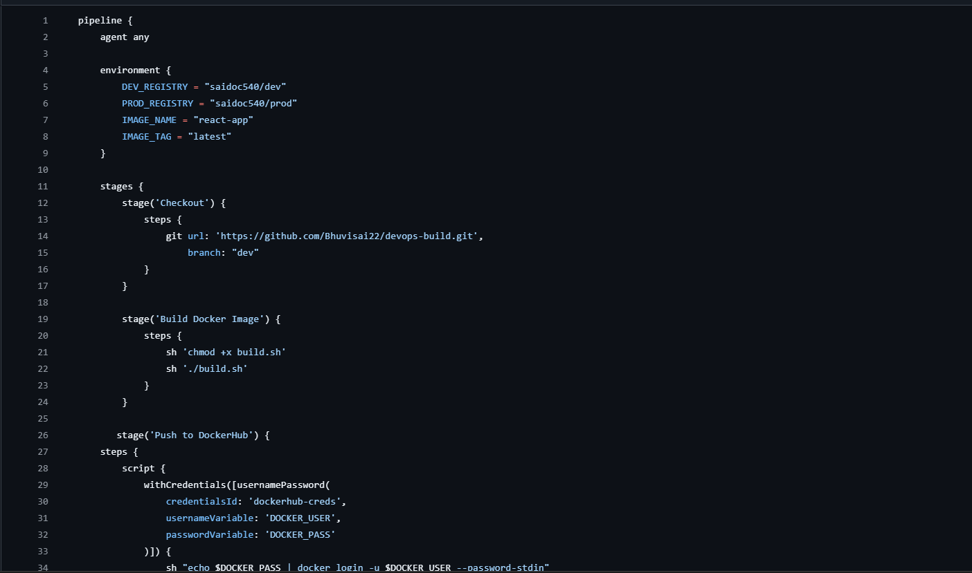 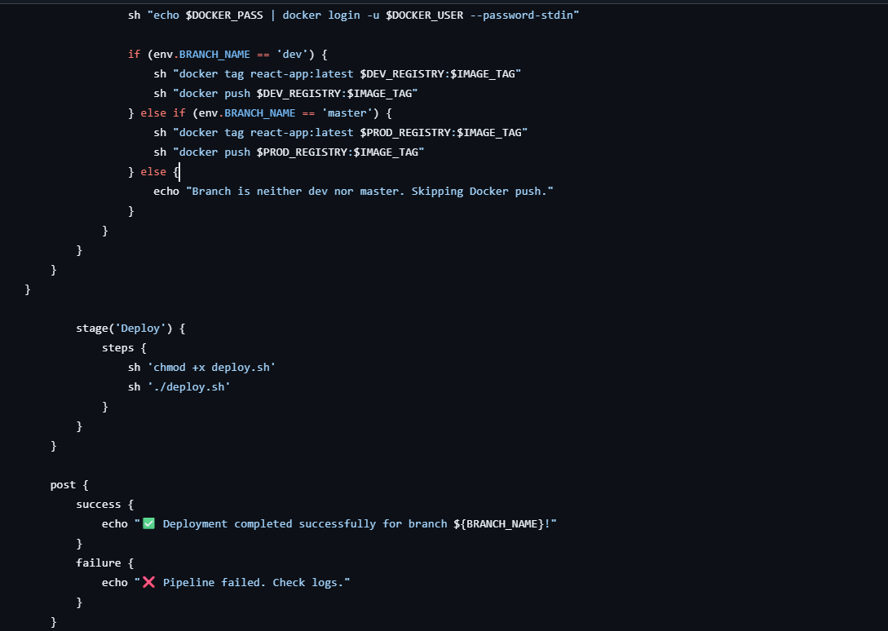
* Console output for **dev branch**: 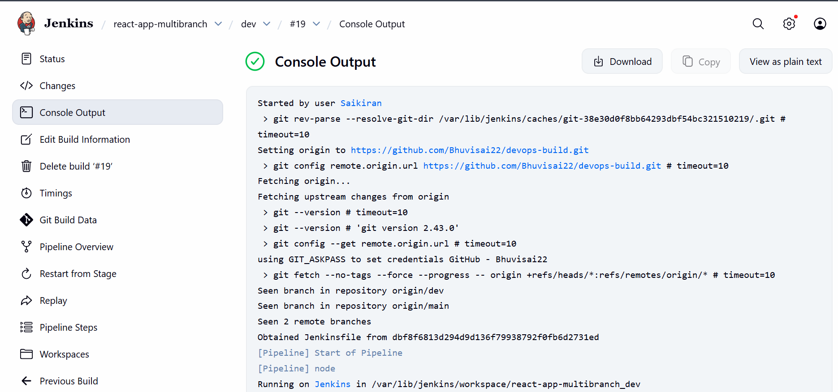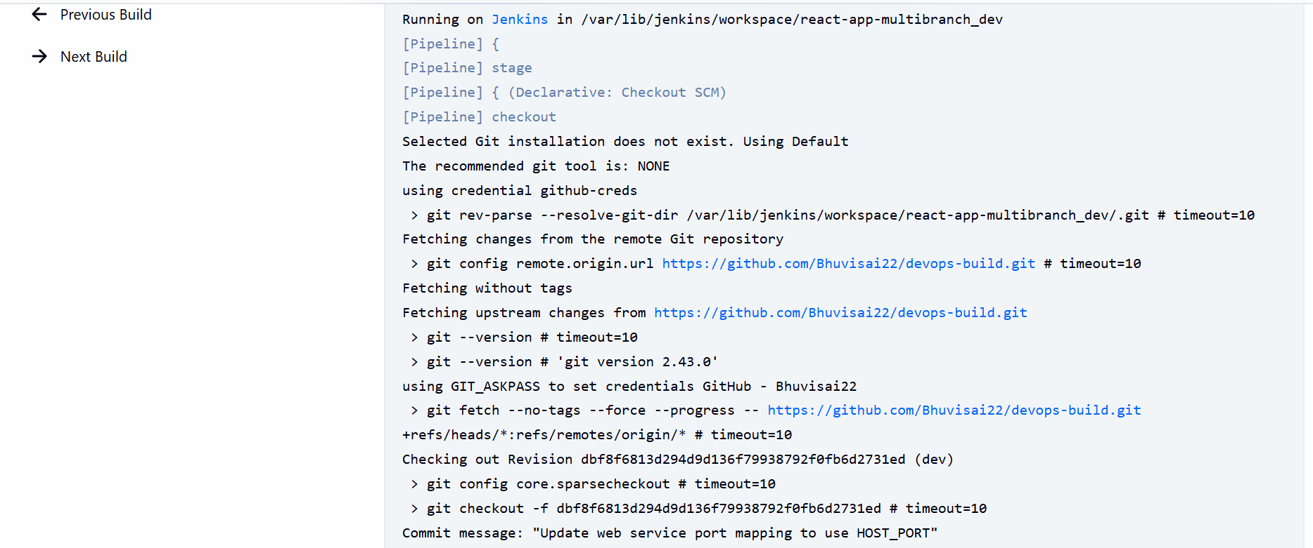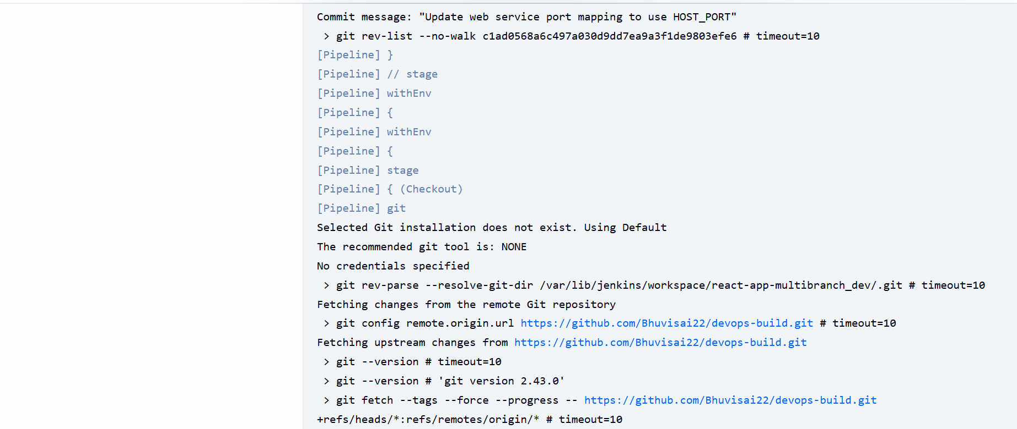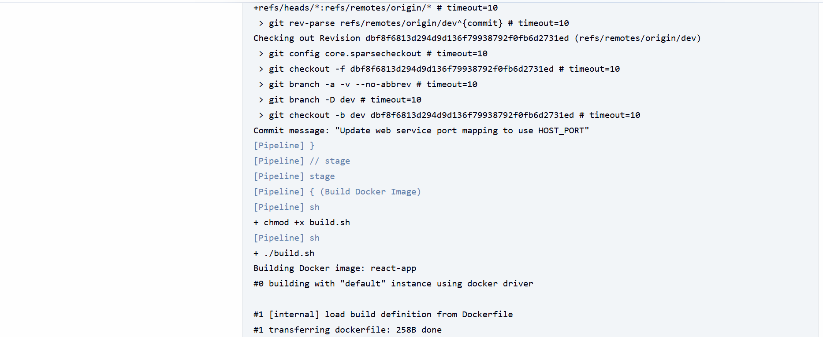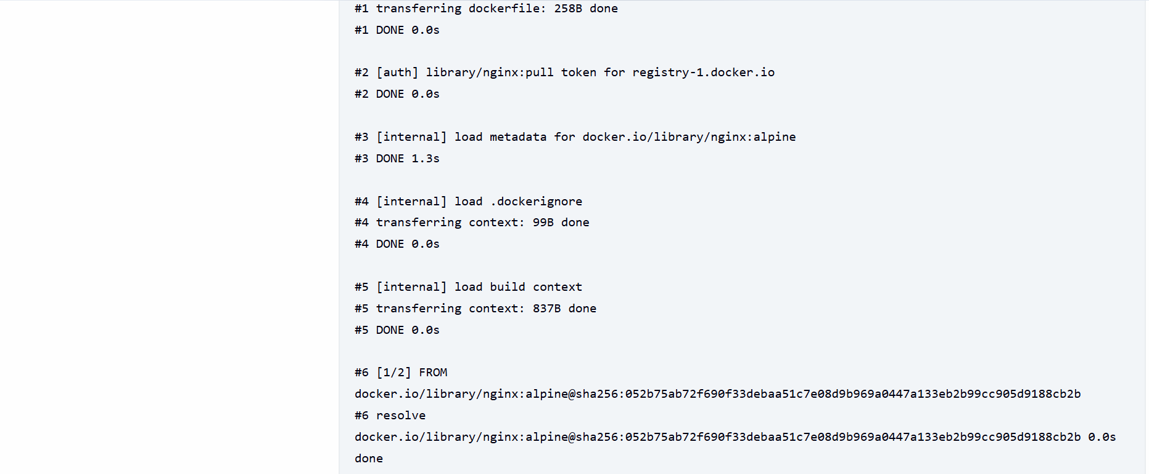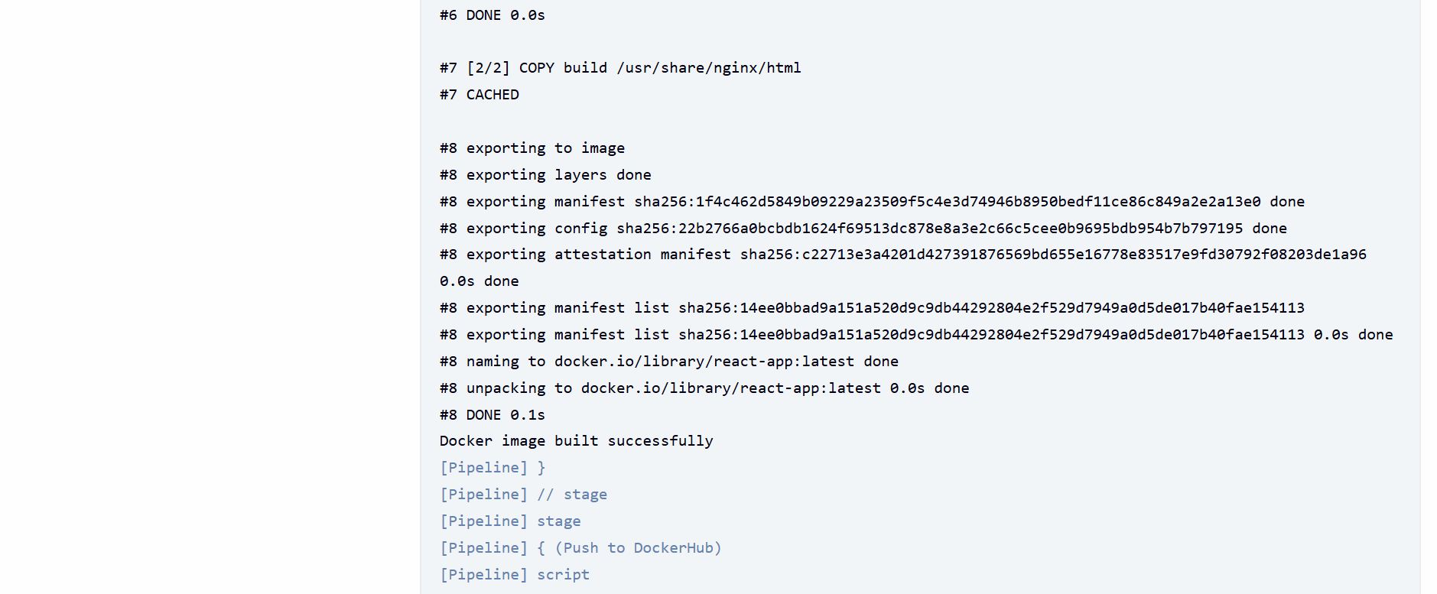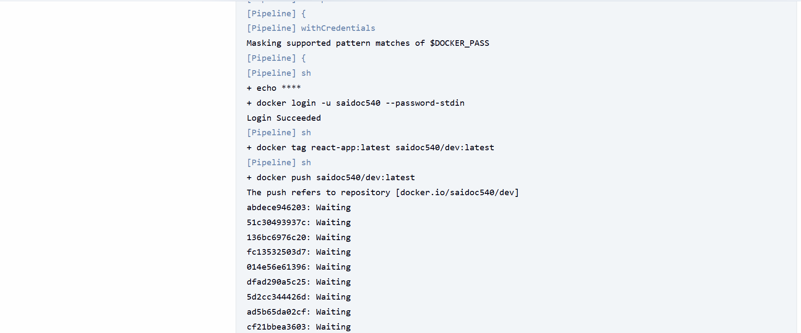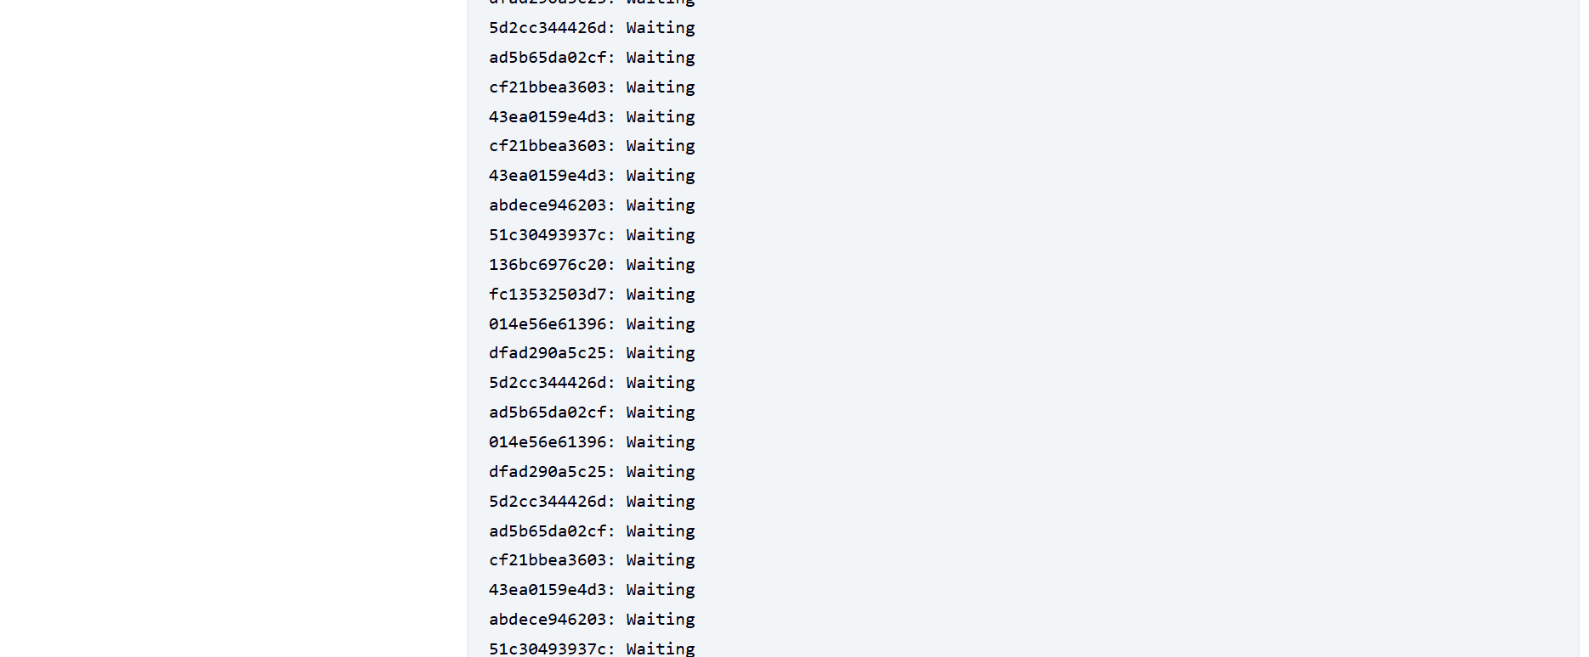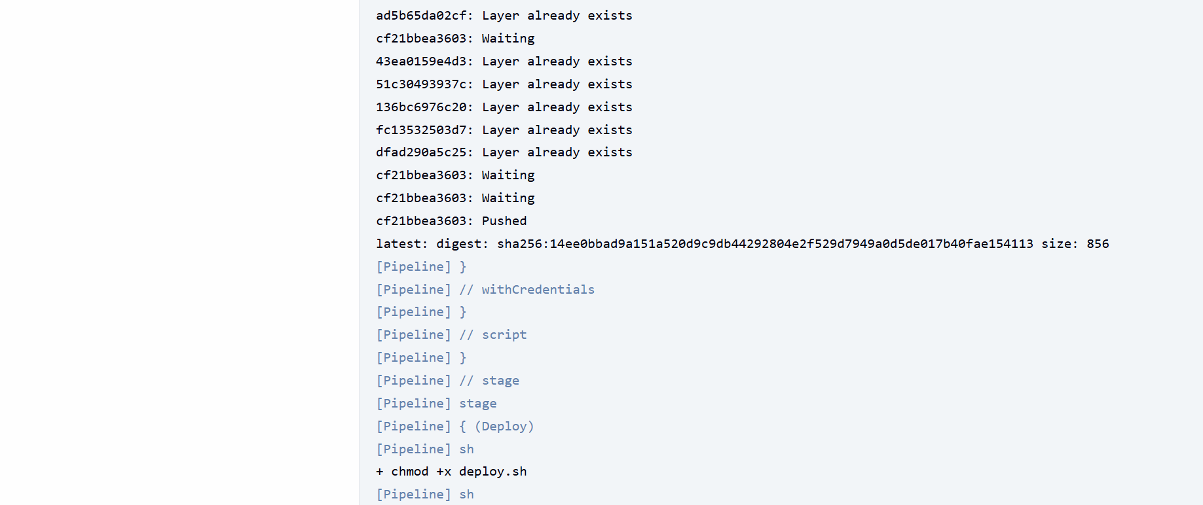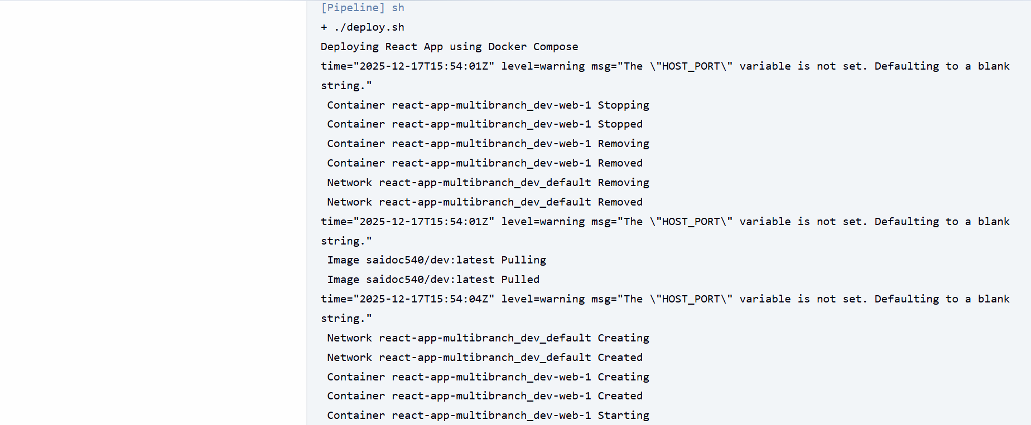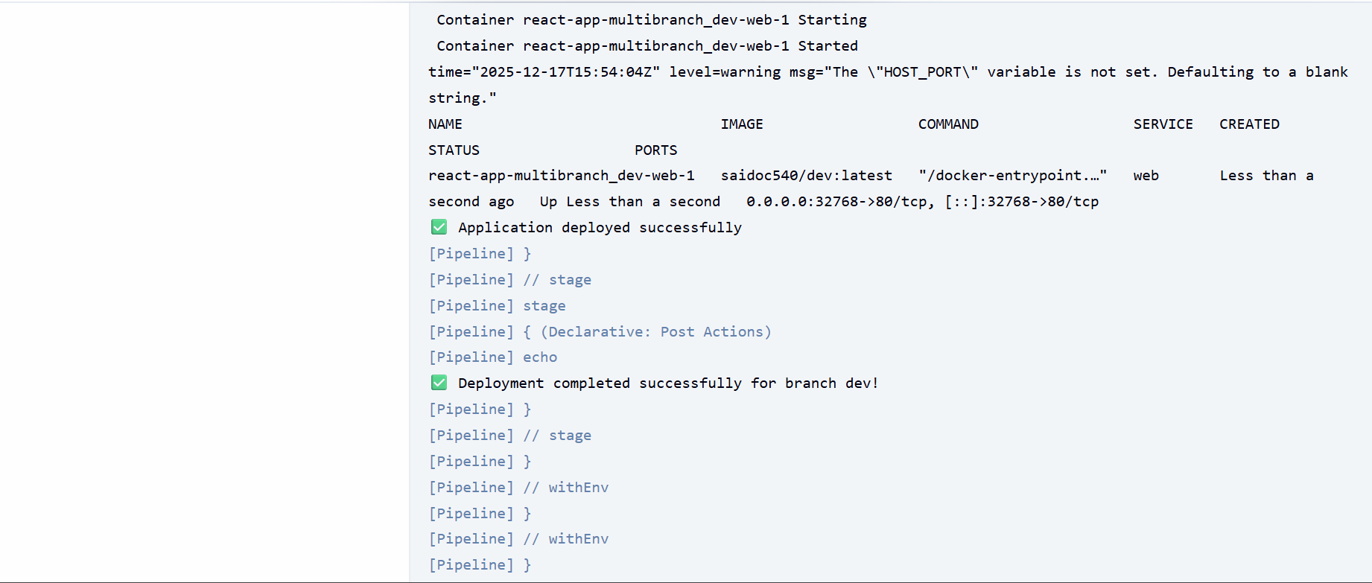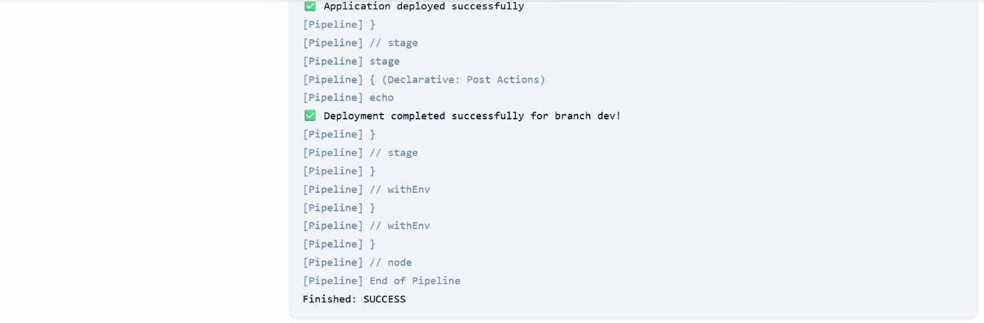
* Console output for **main branch** :

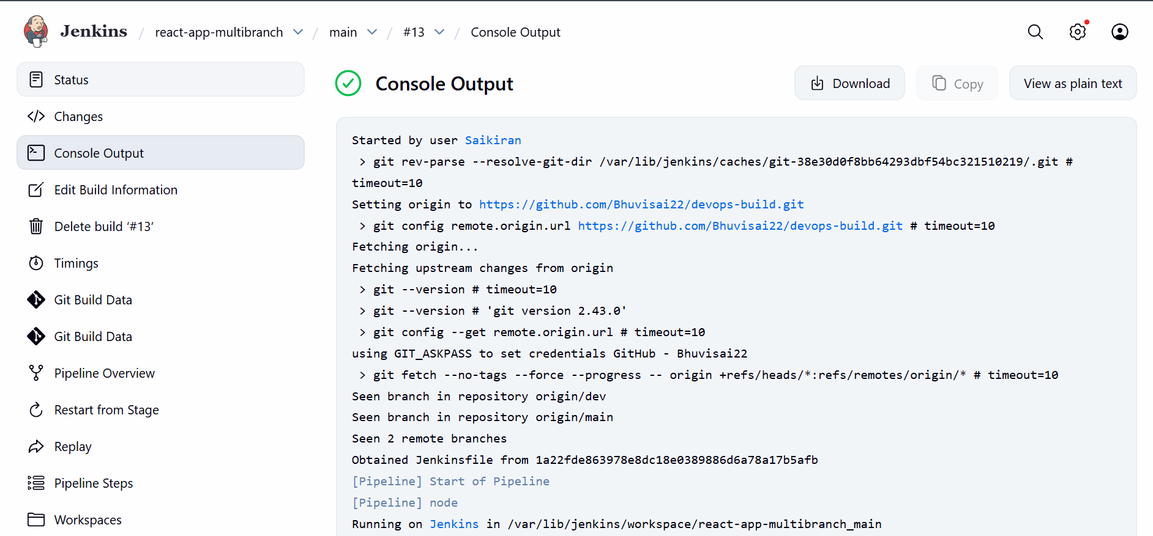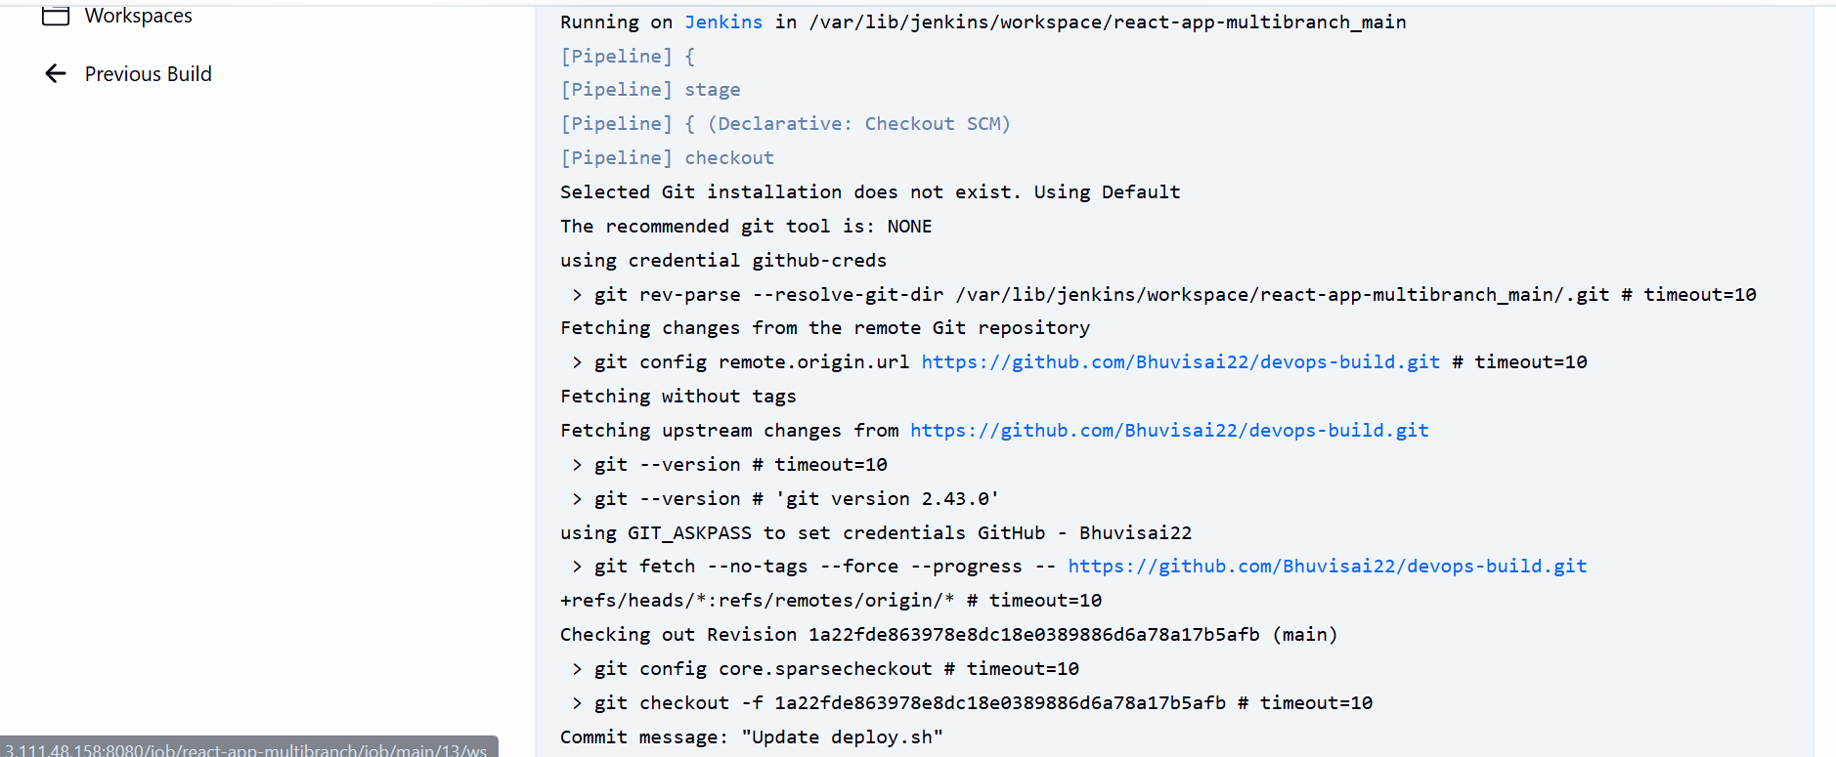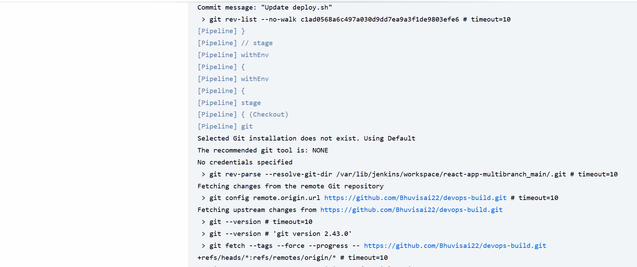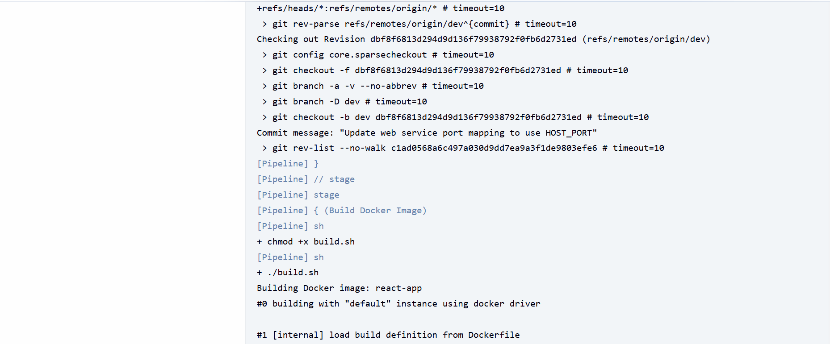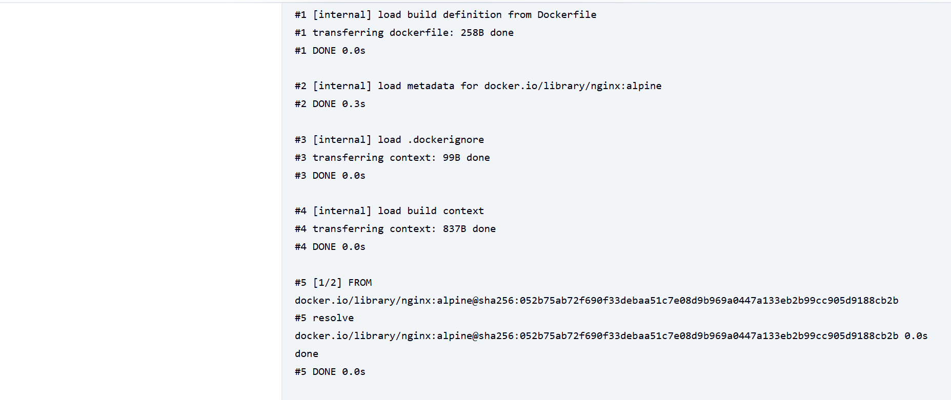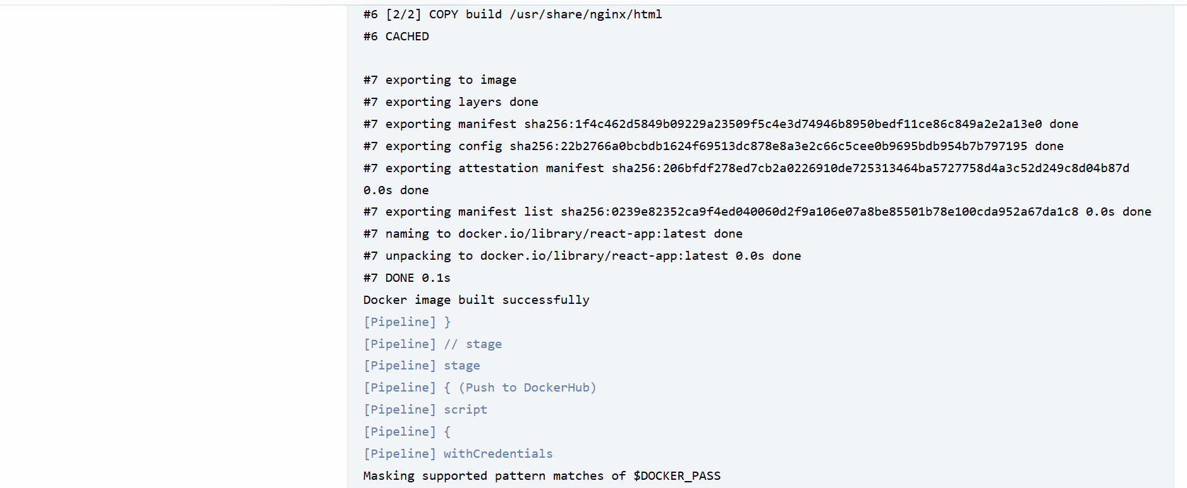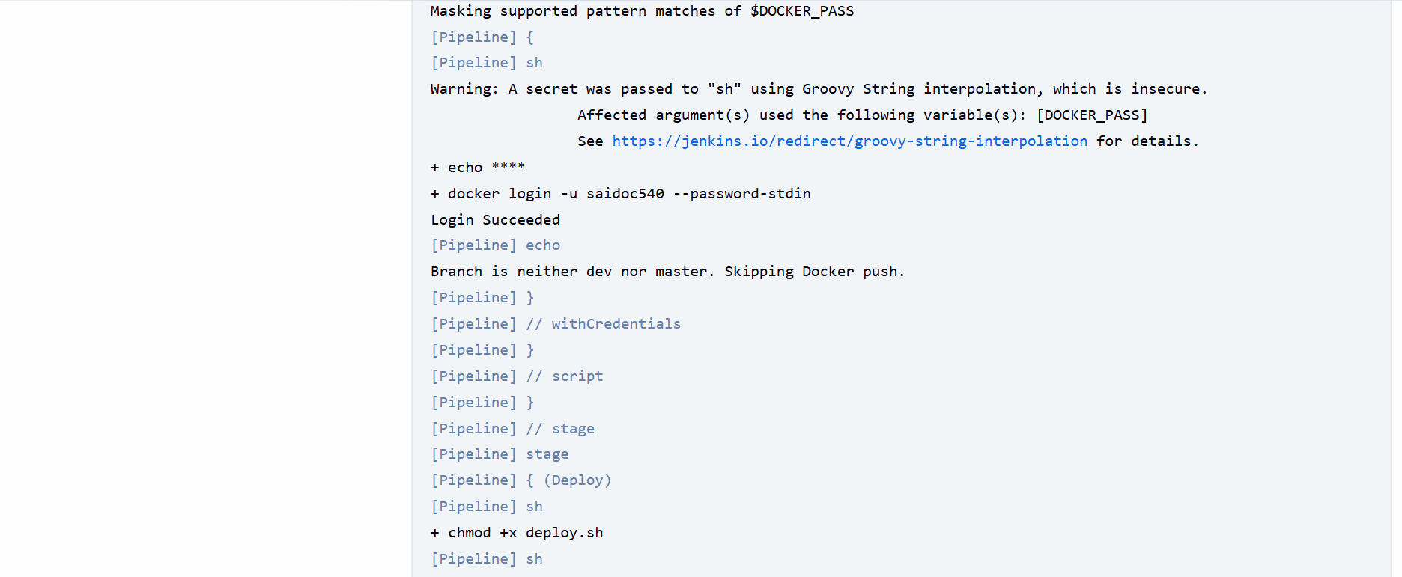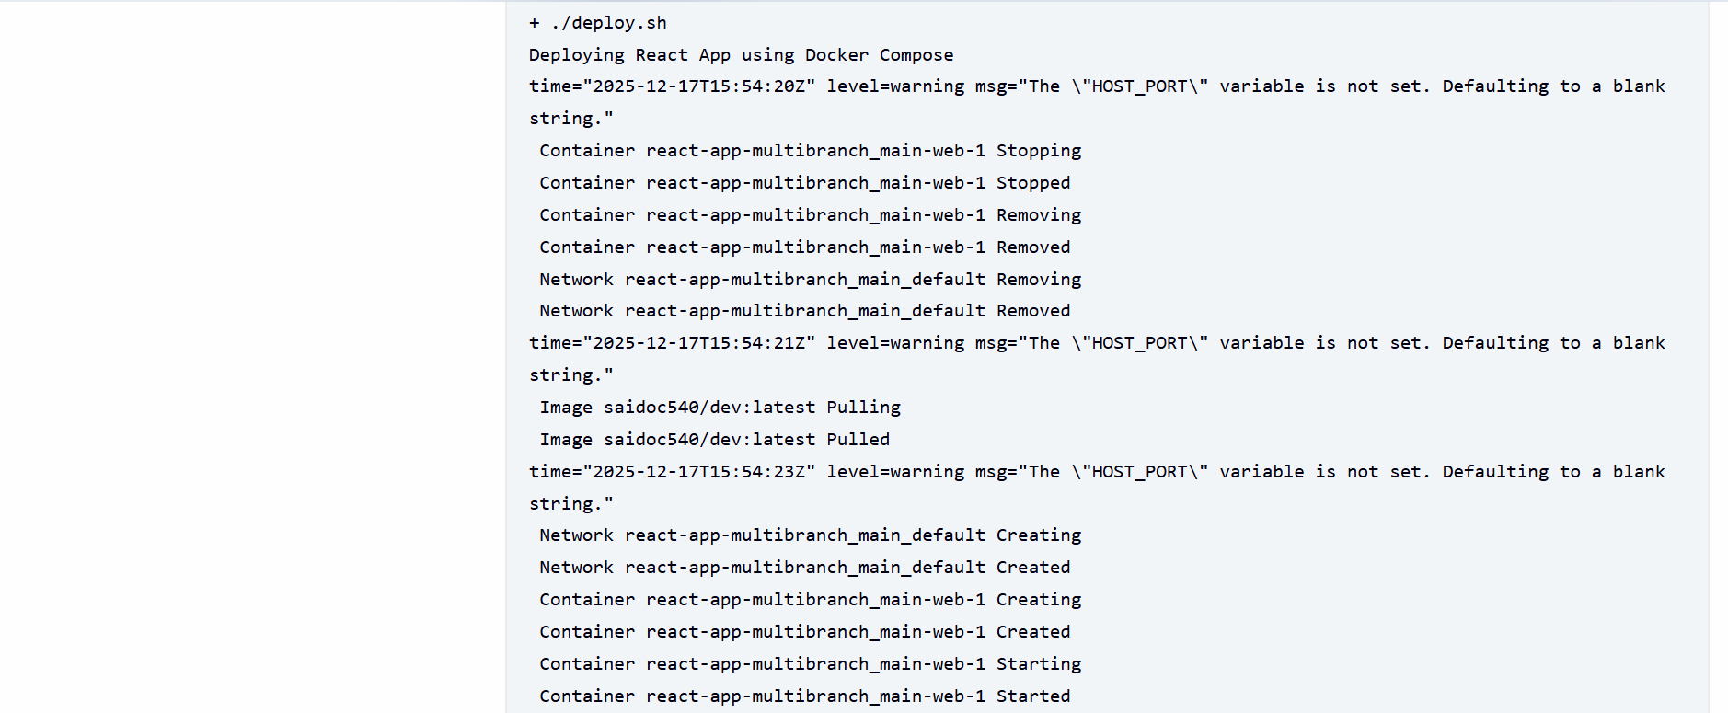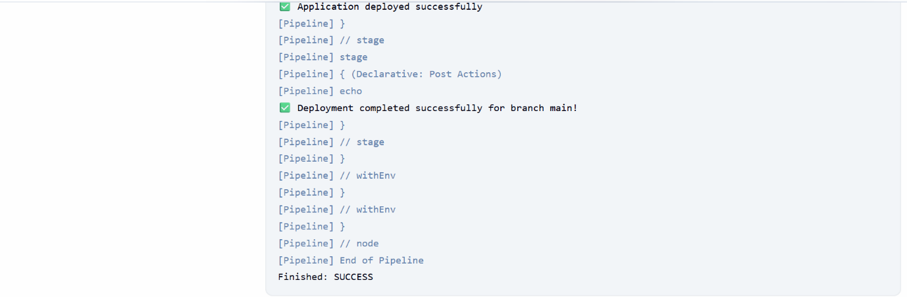

1. AWS:

* **AWS EC2 Setup:** EC2 is just a virtual server. We’ll:
  + Launced a t2.micro instance
  + Installed Docker & Docker Compose
  + Copied our deploy script to it
  + Ran the container on port 80

Security Groups:

* Port 80 open to all → so everyone can see the app.
* Port 22 (SSH) only for your IP → so only you can log in.

Connected to EC2 from local machine:

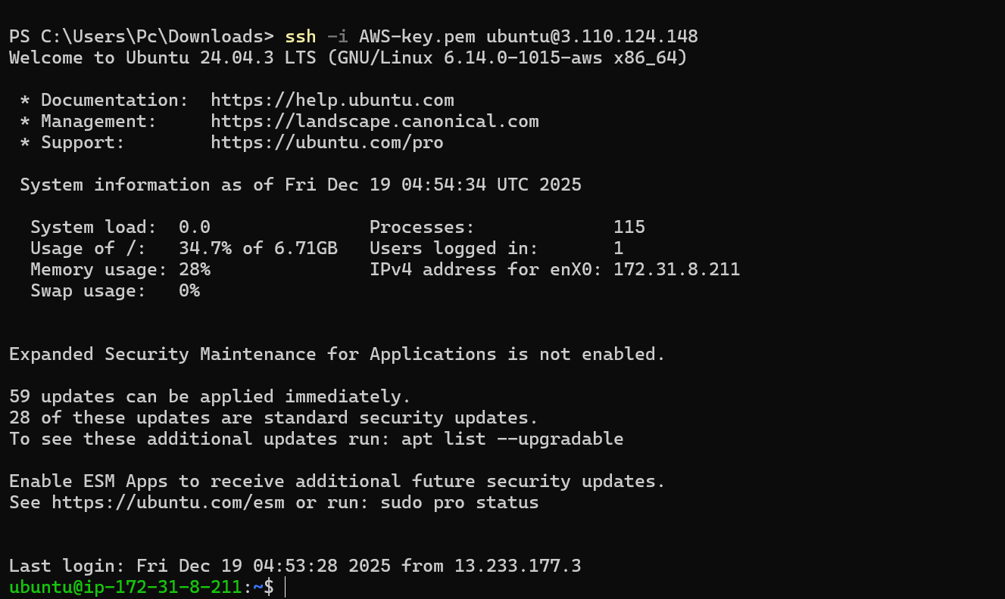

* Created the deploy.sh in ec2 server:

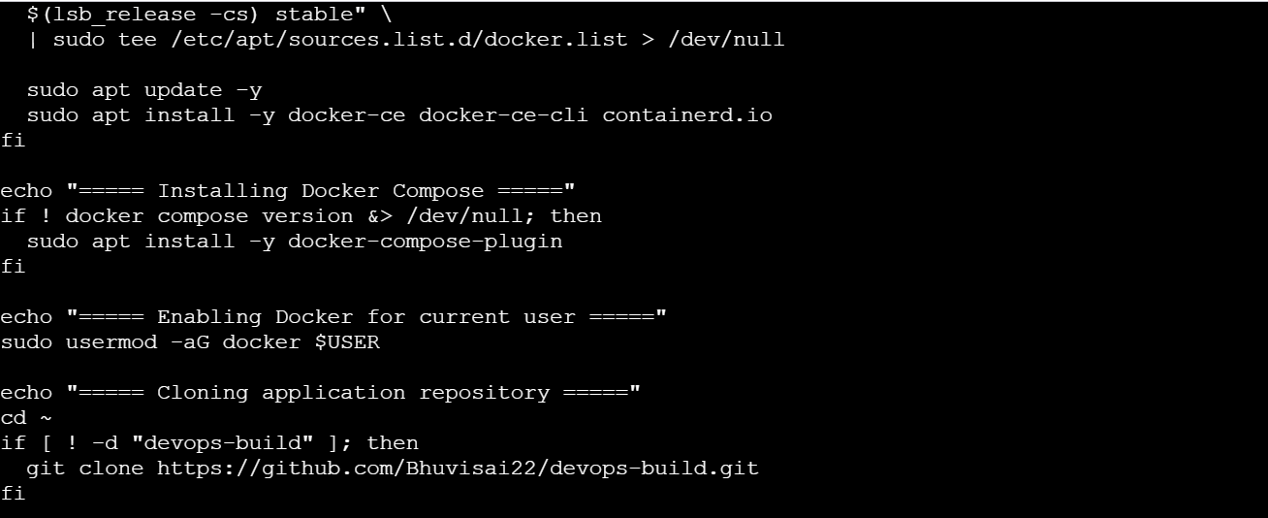

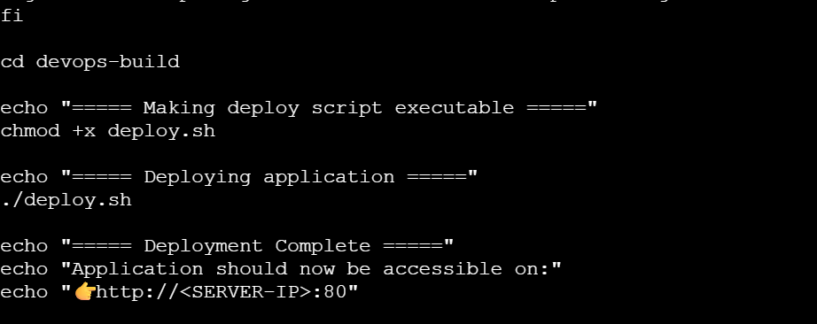

Then executed the deployment script and run by using the commands:

chmod +x deploy.sh

./deploy.sh

Finally got output with port 80:

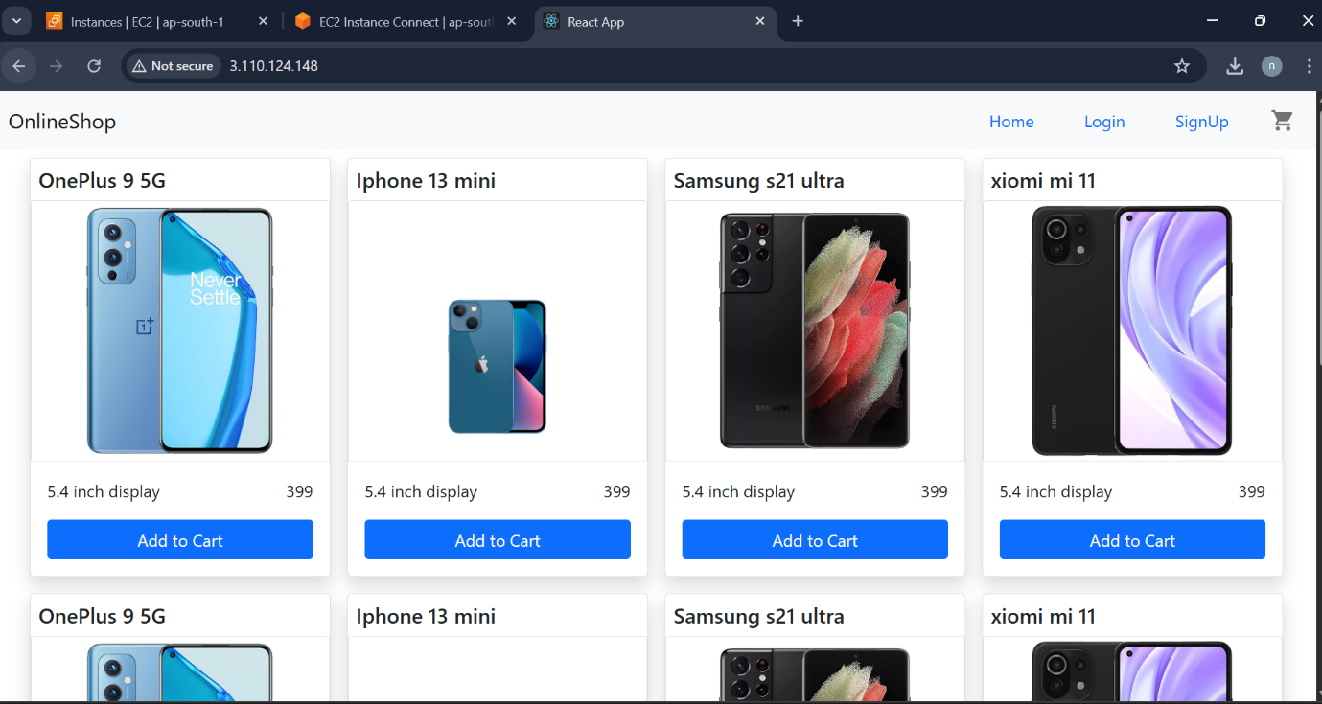

1. Monitoring:

* Created a container in EC2 instance:





Monitored system by Uptime Kuma: 